What is template?
Template is file (HTML file) but it can any file.
Template is an HTML file.
Template is a dynamic HTML file.
Template is collection HTML tags, css, javascript and template tags.
Template allows to separate business logic and presentation logic.
In application development template is used for building presentation logic.

Basic steps for working with templates
- Create templates folder
  - Project container folder
  - Application folder
- Create template (html)
- Include template within view (rendering process)
- Template path (settings.py)

Views.py
def view1(request):
response=render(request,"first.html")
return response

urls.py
path('view1/',view1)

settings.py
INSTALLED_APPS = [
'django.contrib.admin',
'django.contrib.auth',
'django.contrib.contenttypes',
'django.contrib.sessions',
'django.contrib.messages',
'django.contrib.staticfiles',
'app1',
]

TEMPLATES = [
{
'BACKEND': 'django.template.backends.django.DjangoTemplates',
'DIRS': [BASE_DIR/"templates"],
'APP_DIRS': True,

PS D:\Backup\Django9amMar> django-admin startproject project4
PS D:\Backup\Django9amMar> cd project4
PS D:\Backup\Django9amMar\project4> python manage.py startapp app1
PS D:\Backup\Django9amMar\project4>

views.py
from django.shortcuts import render

# Create your views here.
def listemp(request):
emp={'empno':1,
'ename':'naresh',
'job':'manager',
'salary':50000}
response=render(request,"app1/templates/employees.html",context={'emp':emp})
return response

def resultview(request):
student={'rollno':1,
'name':'naresh',
'sub1':60,'sub2':80}
result="PASS" if student['sub1']>=40 and student['sub2']>=40 else "FAIL"
response=render(request,"studentresult.html",context={'stud':student,'result':result})
return response
def homeview(request):
response=render(request,"home.html")
return response

urls.py
from django.contrib import admin
from django.urls import path
from app1.views import listemp,resultview,homeview
urlpatterns = [
path('admin/', admin.site.urls),
path('listemp/',listemp),
path('result/',resultview),
path('',homeview)
]

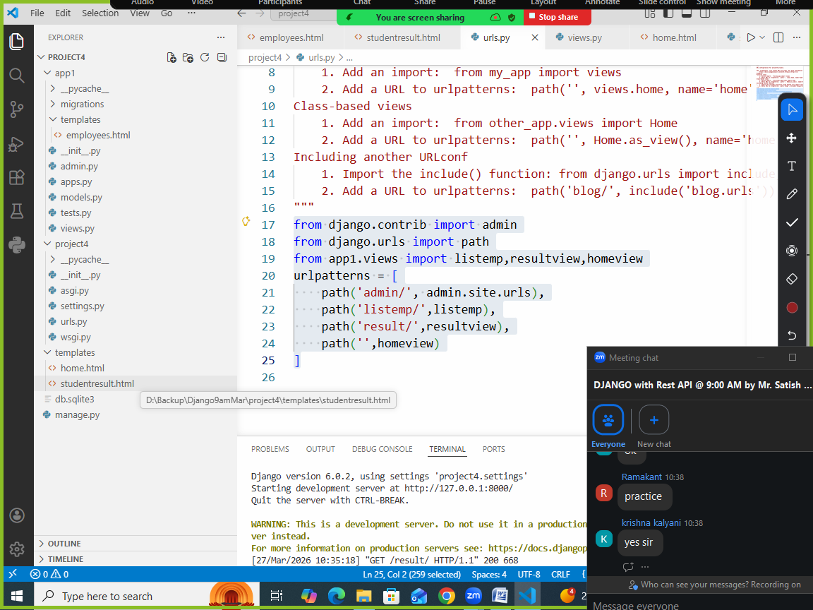

Employees.html
<!DOCTYPE html>
<html lang="en">
<head>
<meta charset="UTF-8">
<meta name="viewport" content="width=device-width, initial-scale=1.0">
<title>Document</title>
</head>
<body>
<table border="3" width="100%">
<tr>
<td>EmployeeNo</td>
<td>{{emp.empno}}</td>
</tr>
<tr>
<td>EmployeeName</td>
<td>{{emp.ename}}</td>
</tr>
<tr>
<td>EmployeeJob</td>
<td>{{emp.job}}</td>
</tr>
<tr>
<td>EmployeeSalary</td>
<td>{{emp.salary}}</td>
</tr>
</table>
</body>
</html>

Studentresult.html
<!DOCTYPE html>
<html lang="en">
<head>
<meta charset="UTF-8">
<meta name="viewport" content="width=device-width, initial-scale=1.0">
<title>Document</title>
</head>
<body>
<table border="2" width="100%">
<tr>
<td>Rollno</td>
<td>{{stud.rollno}}</td>
</tr>
<tr>
<td>StudentName</td>
<td>{{stud.name}}</td>
</tr>
<tr>
<td>Subject1Marks</td>
<td>{{stud.sub1}}</td>
</tr>
<tr>
<td>Subject2Marks</td>
<td>{{stud.sub2}}</td>
</tr>
<tr>
<td>Result</td>
<td>{{result}}</td>
</tr>
</table>
</body>
</html>

Home.html
<!DOCTYPE html>
<html lang="en">
<head>
<meta charset="UTF-8">
<meta name="viewport" content="width=device-width, initial-scale=1.0">
<title>Document</title>
</head>
<body>
<h2>
<a href="/listemp/">List Employees</a><br>
<a href="/result/">Student Result</a><br>
</h2>
</body>
</html>

Settings.py
INSTALLED_APPS = [
'django.contrib.admin',
'django.contrib.auth',
'django.contrib.contenttypes',
'django.contrib.sessions',
'django.contrib.messages',
'django.contrib.staticfiles',
'app1',
]

TEMPLATES = [
{
'BACKEND': 'django.template.backends.django.DjangoTemplates',
'DIRS': [BASE_DIR,BASE_DIR/"templates"],
'APP_DIRS': True,
'OPTIONS': {

